Mitigating the impacts of offshore wind on marine fisheries can also promote climate resilience
Christopher M. Free¹*, Kelly S. Andrews⁴, Pol Carbó Mestre^{1,2,3}, Blake E. Feist⁴, Steven D. Gaines², Ana Sofia Guerra⁴, Tracey Mangin^{1,2,3}, Jameal F. Samhouri⁴, Donna M. Schroeder⁵, Ellen Willis-Norton⁶

¹ Marine Science Institute, University of California, Santa Barbara, Santa Barbara, CA, 93106, USA
² Bren School of Environmental Science and Management, University of California, Santa Barbara, Santa Barbara, CA, 93106, USA
³ Environmental Markets Lab, University of California, Santa Barbara, Santa Barbara, CA, 93106, USA
⁴ Conservation Biology Division, Northwest Fisheries Science Center, National Marine Fisheries Service, National Oceanic and Atmospheric Administration, Seattle, WA, 98112, USA
⁵ Bureau of Ocean Energy Management, 760 Paseo Camarillo, Camarillo, CA 93010, USA
⁶ Port of San Diego, San Diego, CA, 92101, USA

* Corresponding author: Marine Science Institute, University of California, Santa Barbara, Santa Barbara, CA, 93106, USA; cfree14@gmail.com

Target journal: Marine Policy

Key documents: Google Drive | presentation | Ellen table | old text | CBA review document | really helpful meeting folder | mitigation measures database | Ana’s cable/oil agreements | Kelly’s EU/East Coast notes

Key for co-authors
Yellow text = Will get deleted for the BOEM report but retained for the ultimate manuscript?
Blue text = a number that might be to be updated as the work continues

Abstract (250 word maximum)
The rapid expansion of offshore wind (OSW) is essential to achieving global climate goals but is expected to displace commercial fisheries and intensify competition for marine space. While substantial attention has been devoted to avoiding and minimizing these conflicts through marine spatial planning, less guidance exists on how to mitigate impacts that remain after development decisions have been made. We developed a menu of mitigation strategies designed to offset the socioeconomic impacts of OSW development while strengthening the long-term resilience of fishing communities. Using a telescoping review approach, we synthesized mitigation measures from seven complementary sources, including focus groups with U.S. West Coast fishing communities, community benefit agreements (CBAs), proposed CBA templates, official government guidance, and the broader literature on offshore wind and fisheries adaptation. We organized individual mitigation measures into broader mitigation strategies and evaluated their contributions to established frameworks of human well-being and climate resilience. The resulting framework extends beyond direct financial compensation to include investments in port infrastructure, seafood marketing, workforce development, fisheries science, governance participation, vessel safety, innovation, and community capacity. We find that many proposed mitigation strategies strengthen multiple dimensions of socioeconomic and governance resilience, whereas ecological resilience remains comparatively underrepresented. We also demonstrate how CBAs and similar legal instruments can provide flexible mechanisms for financing and implementing locally tailored mitigation portfolios that address both OSW impacts and other major stressors affecting fishing communities. Although motivated by a California case study, the framework is broadly transferable to regions worldwide where offshore wind or other emerging ocean uses intersect with commercial fisheries. By providing a structured menu of mitigation options and a workflow for designing mitigation plans, this study offers practical guidance for promoting equitable coexistence between renewable energy development and marine fisheries.

Keywords (7 word maximum): wind energy, mitigation, compensation, avoidance, minimization, community benefit agreements

Highlights (3-5 bullets; 85 characters max)
- Highlight 1
- Highlight 2
- Highlight 3
- Highlight 4
- Highlight 5

Acronyms
BOEM = Bureau of Ocean Energy Management
CBA = community benefit agreement
CFO = commercial fishing organization
LLC = limited liability company
NREL = National Renewable Energy Laboratory
OSW = offshore wind

1. Introduction
Climate change threatens global food systems and economies (Wheeler and von Braun, 2013), driving the need for renewable energy that reduces emissions and prevents catastrophic impacts (Hoegh-Guldberg et al., 2019; Rogelj et al., 2015). Offshore wind (OSW) is expanding as a valuable source of renewable energy due to greater wind consistency and availability of structure-free space in the ocean compared to land (GWEC, 2025). Although marine fisheries are negatively impacted by climate change (Free et al., 2019) and would experience long-term benefits from emissions reductions (Cheung et al., 2016; Gaines et al., 2018), they are likely to experience negative short-term impacts from expanded OSW development (Gill et al., 2020). Notably, OSW development displaces fisheries, which can result in lost fishing grounds, crowding, lower catch rates, greater travel times, and higher fuel expenditures (Willis-Norton et al., 2024). While OSW sites could generate positive fisheries impacts by acting as de facto protected areas and artificial reefs, both of which can increase local catch rates, these benefits are tenuous (Gill et al., 2025) and are more likely to be offset by the negative impacts resulting from displacement (Gill et al., 2020). Limiting the short-term impacts of OSW development on fisheries is therefore critical for ensuring the longer-term viability of these coastal food systems and to reducing opposition to an emerging source of renewable energy.

The negative impacts of OSW development on marine fisheries can be reduced through avoidance, minimization, and mitigation (BOEM, 2025). Avoiding impacts by siting OSW in areas without fishing is optimal, but is challenging when the best fishing grounds and wind areas overlap (Feist et al., 2025). Minimizing impacts through effective OSW siting, design, and communication is necessary when impacts cannot be fully avoided. For example, impacts can be minimized by siting OSW in windy areas of low fisheries importance or by arranging turbines and cables in ways that limit displacement (Boussarie et al., 2023; Carlton et al., 2023; Harvey et al., 2025; Zhang et al., 2017). Finally, mitigating impacts that remain after avoidance and minimization efforts is a last, yet nearly universal, resort (Szostek et al., 2025). Mitigation measures include the compensation of impacted fishermen through direct monetary payments and/or through investments in the fishery that indirectly benefit impacted fishermen and communities by bolstering their income, resilience, or well-being (Reilly et al., 2016). While avoidance and minimization is supported by a rich literature on marine spatial planning (Boussarie et al., 2023; de Groot et al., 2014; Stelzenmüller et al., 2022; Zhang et al., 2017), the role of mitigation, especially in offsetting impacts through investments that holistically increase income, resilience, or well-being, is relatively underexplored (Reilly et al., 2016).

While mitigation measures directly pertaining to OSW development and the fisheries it displaces offer the most linear pathway for mitigating OSW impacts, measures that bolster against other stressors or support less-displaced fisheries may be as or more effective. In many places, fishermen participate in fisheries outside those affected by OSW development, which suggests that measures that improve the profitability or resilience of these other fisheries could offset losses in those affected by OSW. Similarly, OSW development is just one of many stressors confronting fishermen, who must also contend with climate change, market fluctuations, changing management restrictions, and rising spatial conflicts with marine protected areas (MPAs), aquaculture, and other emerging ocean uses (Trifonova et al., 2025). This suggests that measures that increase resilience to non-OSW stressors could also offset losses related to OSW development. These indirect measures are promising because they broaden the range of strategies that can be used to mitigate OSW impacts. Furthermore, these strategies may prove more effective than direct measures if the mitigated stressor or fishery is more important or easily addressed than the direct OSW impact.

The profits generated from OSW development present a potential pathway for financing fisheries mitigation measures through either legal requirements or effective incentive mechanisms. For example, in the United States, Community Benefit Agreements (CBAs), which are legally binding and enforceable contracts between project developers and impacted community groups, present one promising incentive mechanism for financing, defining, and enforcing fisheries mitigation measures (Hoff and Segal, 2023). These contracts could be used to dictate how energy companies compensate displaced fishermen, refund lost or damaged gear, improve port infrastructure, support community projects, retrain fishermen, or implement other measures identified by the impacted community (CA CFOs, 2022). In return for these benefits, CBAs generally require that the impacted community formally support the planned OSW project, or at least refrain from outwardly opposing it, which lowers long-term litigation and mitigation costs (Hoff and Segal, 2023). Although CBAs have been widely used in land-based development projects, their application in offshore projects is nascent and existing examples rarely include fisheries-specific mitigation strategies (Hoff, 2024). As OSW expands in the U.S. (Perry and Heyman, 2020) and beyond (GWEC, 2025), there is great need for guidance on the actions that could be included in CBAs or similar legal contracts to mitigate the impacts of OSW development on fishing communities.

The goal of this paper is to provide a menu of measures for mitigating the impacts of offshore wind development on marine fisheries through strategies that holistically increase income, resilience, and well-being. We develop this menu through a telescoping review procedure that narrowly begins with a California case study and methodically widens the field of view to examine other U.S. offshore wind farms, official U.S. mitigation guidance, and the wider literature. We identify the elements of human wellbeing and climate resilience supported by the curated mitigation measures to help planners strategically select measures that holistically mitigate OSW impacts. Finally, we discuss the strengths, weaknesses, and special considerations associated with many of the identified mitigation measures. We envision that this typological mitigation framework could be used in the context of other ocean uses that impact marine fisheries, including the expansion of offshore aquaculture; critical minerals mining; oil, gas, and other renewable energy extraction; and ocean protection.

2. Methods

2.1 Overview
We used a “telescoping” review procedure to identify mitigation measures that narrowly begins with a specific case study (planned OSW areas in California) and methodically widens the field of view to other sources (Fig. X). Specifically, we extract mitigation measures from seven sources: (1) focus group discussions held with fishermen from three West Coast port communities; (2) a CBA between Castle Wind LLC and one California commercial fishing organization; (3) a CBA template proposed by sixteen California commercial fishing organizations; (4) mitigation guidelines prepared by the 7c Working group; (5) CBAs already implemented for other offshore projects in the U.S; (6) recent government guidance on mitigating OSW impacts on fisheries in the U.S.; and (7) select review papers describing strategies for mitigating the impacts of OSW and climate change on fisheries. We extracted distinct mitigation “measures” from each source then grouped them into broader mitigation “strategies.” As a result, each broad mitigation strategy is exemplified by examples of specific mitigation measures. Finally, we identified which constituents of human wellbeing (Breslow et al., 2016) and which attributes of climate resilience (Mason et al., 2022) are supported by each mitigation strategy. This serves two functions. First, it reveals the preferences and shortcomings of each source of mitigation measures regarding measures that support wellbeing or resilience. Second, it allows designers of future mitigation plans to select mitigation strategies that holistically support each realm of human wellbeing and climate resilience. All analyses were done in R (R Core Team, 2026) and all non-confidential data and code associated with the manuscript are available on GitHub here: https://github.com/cfree14/osw_mitigation_measures

2.2 Case study
The first OSW on the U.S. West Coast is planned for two areas off of California (Fig. 1A). The Morro Bay lease area (975 km²) is over 31 km (>867 m deep) off of Morro Bay in Central California while the Humboldt lease area (536 km²) is over 32 km (>510 m deep) off of Eureka in Northern California (Boren, 2021; Liu, 2021). These areas were identified by the Bureau of Ocean Energy Development (BOEM), the U.S. federal agency that permits and regulates ocean energy projects, through a 5-year data- and stakeholder-informed planning process (BOEM, 2026a). Ultimately, the areas were sited based on revisions following two rounds of public comment, plus an initial round of outreach by Trident Winds LLC, the wind company that first proposed a wind development project in the Morro Bay area. Although the areas were successfully auctioned and leased in 2022, site characterization and other developer activities are stalled due to changes in federal priorities (The White House, 2025). At the time of writing, two winning companies have relinquished their leases over two parcels in the Morro Bay area, though the state of California is disputing the legality of these arrangements (CA DOJ, 2026).

The commercial fishing industry anticipates large and diverse negative impacts as a result of OSW development in California (CA CFOs, 2022). The principal concern regards loss of access to fishing grounds, especially for highly migratory species and deepwater groundfish, within the lease areas. This is expected to reduce catches and increase transit times, resulting in higher fuel expenditures, lower product quality, and more time away from family. There are also concerns that OSW development will reduce safety at sea, stifle climate adaptation, hinder scientific monitoring, harm the environment, and hurt stock health. Fishermen also anticipate that increased port activity will disrupt normal transit patterns and increase competition for limited harbor space, which could price out fishing vessels. Additionally, they are worried about eroding community identity, dilution of the symbiotic relationship between fishing and tourism in small coastal towns, and increased personal and family stress due to increased economic strain and time at sea. This brief summary highlights only a fraction of the concerns raised by sixteen California commercial fishing organizations in their letter to regulators (CA CFOs, 2022).

The lease agreements between BOEM and the wind developers did not include specific project-level mitigation measures for fisheries. However, the leases did require the development of a Native American Tribes Communication Plan and a Fisheries Communication Plan, which established formal engagement between the lessees and the affected community to help identify measures to avoid, minimize, and mitigate potential adverse impacts. Specific mitigation measures are developed through the Construction and Operations Plan (COP) development and review process, during which BOEM conducts environmental review and consultation before deciding whether to approve the project.

The leases did introduce a new bidding mechanism to incentivize fisheries mitigation in its auction of the California lease areas (BOEM, 2022a). Specifically, BOEM gave companies the option to increase the total value of their bid by committing up to 30% of their cash bid to (1) workforce training and supply chain development (20% cap), (2) “Lease Area Use CBAs” with commercial or tribal fishing entities that rely on resources harvested within the lease area (5% cap), or (3) “General Use CBAs” with any entity affected by OSW development, including development activities occurring outside the actual lease areas (5% cap). The leases established basic requirements for each type of CBA, but the specific provisions are to be developed collaboratively between the lessees and the affected entities through long-term engagement. Developers were incentivized to commit funding toward CBAs because they received bidding credits for doing so, increasing the value of their bids, while also potentially helping to address stakeholder concerns. Nearly all of the winning bids utilized this option, resulting in $117.4 million for workforce training, $29.4 million for CBAs for fisheries-specific mitigation, and $23.3 million for CBAs for general community mitigation (BOEM, 2026b).

2.3 Focus groups
We conducted focus groups in three ports along the US West Coast to discuss the observed and expected impacts of OSW development and climate change on fisheries and potential strategies for mitigating these impacts. These ports – Morro Bay (Central California), Eureka (Northern California), and Newport (Southern Oregon) – were selected due to their proximity to the recently leased OSW development areas and other proposed areas in Oregon (Fig. 1A). We recruited 3-7 fishermen (one harbormaster also participated) to each focus group (Newport=3 participants, Eureka/Morro Bay=7 participants each). Participants were recruited through a combination of direct outreach to existing professional contacts and through snowball sampling. For the latter, we contacted leaders of commercial fishing organizations, who distributed invitations to participate through their professional networks. We facilitated a structured conversation to first discuss observed and expected impacts of OSW development and climate change on local fisheries and then to discuss potential strategies for mitigating both impacts. See Appendix A for details on the structured conversation. After each focus group, we identified distinct mitigation measures proposed by participants from our notes. The research protocol (#1-23-0595) was approved by the University of California, Santa Barbara (UCSB) Internal Review Board (IRB).

2.4 Community benefit agreements
We extracted mitigation measures from proposed and implemented CBAs for mitigating impacts of offshore and land-based wind projects on impacted communities. These included: (1) a CBA drafted, though never implemented, between a wind company, a city, and two commercial fishing organizations related to the Morro Bay lease area (section 2.4.1); (2) a CBA template proposed by sixteen California fishing organizations for future CBAs with the winning wind companies (section 2.4.2); a CBA template proposed by a state-mandated working group of key constituents (section 2.4.3) and (4) CBAs implemented between wind companies and communities elsewhere in the U.S. (section 2.4.4). These CBAs are described in detail below.

2.4.1 Castle Wind CBA
Before the 2022 auction of the California lease areas, Castle Wind LLC, a joint venture between Trident Winds LLC and TotalEnegies, negotiated and signed a CBA with the City of Morro Bay and two commercial fishing organizations (Morro Bay Commercial Fishermen’s Organization and Port San Luis Commercial Fishermen’s Association). The CBA guaranteed job training, infrastructure improvements, and other benefits for fishermen impacted by the proposed wind project. Through the CBA, the city of Morro Bay also gave Castle Wind the exclusive option to lease an outfall conduit near the Morro Bay power plant that could deliver offshore electricity to the Morro Bay Substation, which illustrates the benefits that CBAs can generate for developers. Castle Wind and the two fishermen’s organizations formed the Morro Bay Lease Areas Mutual Benefits Corporation to facilitate the implementation of the CBA. Although Castle Wind did not ultimately acquire a lease in the 2022 auction, this CBA serves as a starting point for those that could be developed between winning bidders and fishing communities and offers a range of fishermen-endorsed mitigation measures.

2.4.2 California fishing organization CBA template
In 2022, sixteen California commercial fishing organizations, including both organizations involved in the Castle Wind CBA, co-signed a letter to regulators (CA CFOs, 2022) to share a template for a CBA or other legal entity that could be used to manage the impacts of OSW development on California fisheries. Broadly, the document suggests that the entity would negotiate with OSW companies for financial compensation in addition to other types of mitigation and would facilitate communication between the wind company and fishermen. It envisions the distribution of an initial one-time payment as well as continued funding for the duration of the project. It recognizes that more than one entity may be needed to address different regional needs but suggests that the overall purpose and structure of the proposed template is transferable. It also suggests that the model may apply to future reasons for displacement, for example, by offshore aquaculture projects. As with the focus groups and the Castle Wind LLC, this letter provides a range of fishermen-endorsed mitigation measures.

2.4.3 7c Working Group
The U.S. Coastal Zone Management Act requires that all federal activities affecting the coastal zone be consistent with a state’s coastal management program. Thus, as part of the lease approval process, BOEM was required to evaluate the consistency of the proposed lease activities with California state law for the California Coastal Commission to approve or reject. The California Coastal Commission determined that the proposed lease activities were consistent with California's Coastal Management Program conditional on seven requirements (CCC, 2022a, 2022b). Notably, Condition 7(c) called for the development of a “Statewide Strategy for the Coexistence of California Fishing Communities and Offshore Wind Energy.” In 2023, this condition was codified into the California Public Resources Code through California Senate Bill 286. Later in 2023, the “7c Working Group” – composed of representatives from fisheries (n=8), fishing organizations (n=3), wind companies (n=5), and tribes (n=3) – was convened to draft a statewide strategy for “best practices for addressing impacts to the commercial and recreational fishing industries, tribal fisheries, and environmental resources associated with offshore wind energy projects.” The statewide strategy, colloquially called the “7c Working Group Report”, was released in 2026 (7c Working Group, 2026). This document is intended to serve as the authoritative guide for avoiding, minimizing, and mitigating the impacts of OSW development on California’s fishing communities.

2.4.4 Other CBAs developed for offshore or land-based wind projects
In the U.S., CBAs and other forms of community benefits have been developed for a number of offshore wind projects. We reviewed 14 offshore wind agreements (Fig. 1) collated by the National Renewable Energy Laboratory (NREL) in the WINDExchange Local Benefit Mechanisms Database (NREL, 2024) for distinct mitigation measures.

2.5 BOEM mitigation guidelines
In November 2021, BOEM published a “Request for Information” to obtain input from the public, especially the fishing community, on avoiding, minimizing, and mitigating the impacts of OSW development on commercial and recreational fisheries (BOEM, 2021a). The 45-day comment period resulted in 92 public comments (BOEM, 2022b). During this time, BOEM also hosted a series of workshops with commercial and recreational fishing communities spanning the East Coast, West Coast, and Gulf of Mexico (BOEM, 2021b). BOEM published Draft Fisheries Mitigation Guidance in June 2022 (BOEM, 2022c), which received 87 comments during the following 60-day public comment period (BOEM, 2022d). During this time, BOEM hosted another round of workshops with commercial and recreational fishing communities spanning the East Coast, West Coast, and Gulf of Mexico to facilitate direct feedback from fishermen (BOEM, 2022e). After revisions based on these comments, BOEM announced the finalization of a national framework for addressing the social and economic impacts of OSW development on the fishing industry (BOEM, 2025). While the draft guidance, public comments, and workshop notes provide a rich database of potential mitigation measures, we only evaluated the final guidance because of its regulatory authority and significance.

2.6 Selected review papers
Finally, we reviewed a selective set of review papers on either OSW or climate change mitigation to extract mitigation measures that could increase the resilience of fishing communities to either OSW or climate change. Although less comprehensive than a systematic literature review, this targeted “mini-review” strategy kept the scope of the search manageable, allowing us to deliver policy-relevant research more quickly (Donaldson et al., 2011). The papers were identified through a combination of our expert knowledge and a scan of papers identified through a series of keyword searches in Google Scholar. Ultimately, we reviewed X papers on OSW mitigation measures (citations) and X papers on climate change mitigation actions (citations) for potential mitigation measures.

2.7 Mitigations measures database
We collated the mitigation actions identified from the seven sources described above into a single list of mitigation actions. We then reviewed these actions and generalized them into 60 distinct mitigation “measures.” For example, “[fund] radar system upgrades [to improve safe navigation]” and “[provide] safety and navigation equipment grants” were both generalized as “provide vessel safety equipment.” We then grouped mitigation measures into 26 distinct mitigation “strategies”, which capture the broader purpose of each mitigation measure. For example, “provide vessel safety equipment” and “provide vessel safety training” were grouped under “provide vessel safety equipment and training.” As a result, each mitigation measure represents a tactical example of a broader mitigation strategy (Table 1).

We then identified the constituents of human wellbeing and attributes of climate resilience supported by each mitigation strategy. The constituents of human wellbeing are those of the “4Cs” framework described in the introduction (Breslow et al., 2016). The attributes of climate resilience were adopted from the framework put forth by Mason et al. (2022). Through a coupled literature- and expert-driven approach, Mason et al. (2022) defined 38 ecological, socioeconomic, and governance attributes theorized to confer climate resilience in marine fisheries. Within the ecological, socioeconomic, and governance dimensions, these attributes are organized within five resilience domains (Cinner et al., 2018a, 2018a): (1) Assets are ecological or socioeconomic resources that can be drawn upon to buffer impacts or respond to change (not in the governance dimension), (2) Flexibility represents the ability to switch strategies or make other adjustments in the face of change, (3) Organization represents the social and ecological relationships, networks, and institutions that operate at different spatial and temporal scales to confer resilience, (4) Learning is the process by which people and institutions recognize and identify factors contributing to change and analyze possible responses (not in the ecological dimension), and (5) Agency is the capacity and freedom of people to make and act on choices and underpins people's ability to operationalize different aspects of resilience (not in the ecological dimension).

We also categorized the mitigation measures as representing beneficial, capacity-enhancing, or ambiguous fishery subsidies using the framework of Sumaila et al. (2019), which is adopted from previous work (Sumaila et al., 2016, 2010). Sumaila et al. (2019) identifies beneficial subsidies as investments in fishery resource conservation and management, capacity-enhancing subsidies as investments that promote fishery expansion and overexploitation, and ambiguous subsidies as investments that could promote either sustainable management or overexploitation of the resources depending on context. They identify 13 subsidy types within these categories, which are further divided into 33 subtypes. We assigned a subtype, type, and category to each of the identified mitigation strategies (Table 2). In most cases, the mitigation strategies objectively matched one of the Sumaila et al. (2019) subsidy subtypes (e.g., “Promote local seafood through marketing and outreach” is a “marketing support” subsidy). However, some cases required subjective expert judgement to classify the mitigation strategies within the Sumaila et al. (2019) subsidy framework. For example, we classified “retain consultants, lobbyists, lawyers, and other fisheries advocates” as a “fisher assistance program”, although this type of subsidy is not directly described by the Sumaila et al. (2019) framework.

Add text about how we use this to evaluate the preferences and shortcoming of mitigation measures put forward by each source (i.e., do fishermen only want assets and undervalue other resilience domains/wellbeing?; what constituents/domains are poorly represented within the official BOEM guidance?

3. Results

3.1 Focus groups
Across all three fishing ports, participants emphasized the cultural and social importance of fishing. Fishing was consistently described as a “way of life” that provides purpose and community identity and supports domestic food security. Participants characterized West Coast fisheries as highly regulated and ecologically sustainable, with fishermen viewing themselves as environmental stewards. However, many fishermen reported feeling “regulated to extinction” by management restrictions such as area closures and species-specific catch limits. Participants also described struggling with unfavorable market conditions including rising costs, declining prices, shrinking markets, and competition with cheaper and less sustainable imported seafood.

Fishermen across all three ports generally viewed OSW development as “another hit” to an already fragile industry, contributing to “death by a thousand cuts.” They generally expected that the largest impacts of OSW would result from their exclusion from the lease areas, which they anticipate will result in crowding and increased transit times, resulting in increased costs and reduced product quality. They expect that this will limit their ability to adapt to climate change and other stressors. They also expressed concerns that exclusion of scientific surveys from lease areas will reduce the quality of stock assessments and fishery management. Moreover, they emphasize that OSW development threatens culture, community, and identity.

In general, focus group participants preferred avoidance over compensation and other mitigation measures. However, given that complete avoidance did not occur, fishermen expressed that OSW infrastructure should be arranged to minimize impacts and that a community benefits fund should be used to implement mitigation plans. Participants expressed interest in mitigation measures that improve port infrastructure, support local seafood over imported seafood, ease permitting, relax regulations, and support data collection. Participants expressed mixed interest in fisheries insurance programs similar to those used in agriculture. Participants were generally opposed to habitat creation, preferring maintenance of the current ecosystem.

3.2 Castle Wind CBA
The Castle Wind CBA planned to generate community benefits through three approaches: (1) a Community Communications Plan; (2) a Commercial Fishermen’s Agreement; and (3) a commitment to Local Economic Development Activities. The CBA stipulated that Castle Wind would develop and implement a Community Communications Plan that would schedule a series of meetings with residents and local interest groups to discuss all aspects of the project and require the City of Morro Bay to support organizing, promoting, and recording these meetings. This plan would support resilience by promoting participatory and transparent governance (Gov-organization) and access to knowledge (SE-learning).

The CBA committed Castle Wind to achieve local economic development goals throughout the development, operations, and maintenance of the project. Specifically, the CBA required that Castle Wind support the local economy by hiring local residents, using the local supply chain, and relying on local accommodations. It also required that Castle Wind support internship/training programs in local schools and universities and invest in local green infrastructure, such as electric car chargers. Collectively, these actions would support the economic opportunity (SE-flexibility), economic diversity, wealth and reserves (SE-assets), knowledge and learning (SE-learning), and agency (SE-agency) attributes of climate resilience.

The “Fisheries Agreement” portion of the CBA outlined many fisheries benefits. First, it required Castle Wind to consult with fishermen about the design of the farm with a commitment to minimize restrictions on commercial fishing in the project area. Second, it guaranteed training opportunities for fishermen to support the OSW industry and provided fishermen with the right of first offer for qualified services during construction and operation. Finally, it required Castle Wind to make annual contributions to a fishermen-managed fund (a percentage of the annual operating fees paid to BOEM) with the goal of mitigating the anticipated impacts of OSW on the local commercial fishing community and financing new business opportunities. For example, the CBA suggested that the fund could be used to finance equipment purchases or repairs or improvements to slips, docks, and/or storage facilities (SE-assests).The fund could also be used for activities that support the short- and long-term viability of the commercial fishing industry, including low-cost loans, community outreach, college scholarships, and internships.

3.3 California fishing organization CBA template
The CBA template proposed by sixteen commercial fishing organizations has four main pathways. First, the agreement would establish the basis for a constructive long-term relationship between OSW companies, fishermen, and impacted communities. Second, it would provide the mechanism for fishermen to be reimbursed for fishing gear lost or damaged due to OSW structures or activity. Third, it would provide one-time compensatory payment to all regional fishermen as well as additional compensation for all fishermen directly impacted by the OSW and cable areas. The template proposes that the magnitude of payments would be determined based on the previous 10 years of activities within the OSW and cable areas. Finally, the template proposes that a percentage of OSW lease sales should be added to an annually funded fishing fund that will enable local-level projects and programs which provide economic resilience and sustainability to the region's fisheries and related businesses. The template suggests that the board of directors for the CBA should be largely, though not exclusively, formed of fishermen with a history of fishing within the OSW areas.

The CBA template proposes that the annual fund could be used to (1) provide, improve, or maintain port infrastructure (e.g., ice machines, cold storage, hoists, docks; (2) support participation in the fisheries management process; (3) retain consultants, lobbyists, lawyers, and other fisheries advocates; (4) subsidize overhead costs (e.g., fuel, ice, insurance, moorage); (5) provide training opportunities for new entrants; (6) promote local seafood through marketing and outreach; (7) provide vessel safety equipment and training; (8) support gear/vessel innovation and experimental fishing permits; and (9) commission science support, economic impacts reports, and public opinion polls. These support the parenthetically noted domains of climate resilience domains. The specific attributes of climate resilience supported by these mitigation strategies are shown in Fig. X.

The template also suggests that a CBA should include provisions that (1) guarantee right of first offer for OSW-related services; (2) require consultation in the design of OSW and traffic corridors; (3) create protocols for coordinating emergency response including a 24-hour emergency hotline; (4) provide training opportunities for OSW-skills; (5) hold a bond for unforeseen impacts; and (6) conduct collaborative fish stock surveys and biological assessments.

3.4 7c Working Group Report
The 7c Working Group report (7c Working Group, 2026) proposes best practices related to: (1) communication; (2) surveys and data collection to support fisheries characterizations, site activity planning and impact avoidance measures, and gear loss claims process; (3) avoiding and minimizing impacts; (4) mitigating impacts through direct compensation and “resiliency funds”; and (5) unique considerations for tribal fisheries.

The report offers several recommendations for direct compensation. It states that it should be run by independent administrators and should uphold principles of fairness, efficiency, and transparency. Funds should be dispersed quickly and should minimize overhead costs and administrative burdens to maximize payouts to fishermen. Determination of payment eligibility and amount should be evidence-based and use best available data, and there should be a process for appealing initial determinations. It suggests that compensation should also extend to shoreside processors and encourages vessel owners to pass on payments to captains and crew.

The report also recommends establishing a fishermen-led “resiliency fund” to support active fishing communities. It identifies many potential uses of the resilience program, which it groups under the following categories: (1) port infrastructure investments and improvements; (2) safety and navigation; (3) adaptation services for fishermen; (4) certification and vessel upgrade programs to allow fishermen to work for OSW; (5) support for community organization and operations; (6) permit banks; (7) resource enhancement; and (8) cooperative research.

3.5 Other U.S. offshore wind CBAs
Existing CBAs in the U.S. have never explicitly included measures for mitigating fisheries impacts. Instead, these CBAs largely support community projects.

3.6 BOEM mitigation guidance
The BOEM mitigations guidance document (BOEM, 2025) provides detailed guidance on minimizing impacts through project siting, design, and communication, including guidance on how to minimize safety hazards. The document also provides detailed guidance on reimbursing fishermen for lost or damaged gear and on compensating fishermen for impacts through direct payments. However, the document provides little guidance on mitigating impacts through investments in community infrastructure and resilience.

The guidance suggests that compensation for lost or damaged gear should include any attorney fees needed to submit the claim and should include 50% of income lost while gear is out of commission. The guidance suggests that financial compensation should be fair, equitable, and transparent, should be paid based on history rather than on proof of loss in order to reduce administrative burdens, and should be administered to minimize overhead, thereby maximizing payouts to fishermen. The guidance suggests that annual compensation should begin by reimbursing 100% of lost income in year 1, with 10% reductions in payouts annually, until ceasing in year 5 at 50% of the lost income. The document provides detailed guidance on how to calculate exposure of fishermen to OSW impacts; however, the document stresses that this portion of the guidance is only for fixed platforms and not floating platforms.

The guidance offers a few ideas on how to mitigate losses outside of direct compensation including: (1) funding radar system upgrade to improve safe navigation, (2) conducting stock enhancement; (3) supporting marketing initiatives; (4) supporting gear development; and (5) buying out fishing vessels and permits of fishermen deciding to exit fishing.

3.7 Selected review papers
This section will not appear in the BOEM report but will likely appear in the manuscript.

3.8 Cross-source synthesis
Our telescoping review collated 60 mitigation measures grouped within 26 broader mitigation strategies (Table 1). The use of OSW funds to “provide/improve and maintain port infrastructure” was by far the most commonly identified mitigation strategy and was named in all of the sources except the BOEM mitigation guidance (Fig. 2). The use of OSW funds to “subsidize overhead costs” and “promote local seafood through marketing and outreach” were the next most commonly identified mitigation strategies. Strategies that “promote local seafood through marketing and outreach” and “provide vessel safety equipment and training” were the only mitigation strategies proposed within all of the evaluated sources (Fig. 2).
The identified mitigation strategies strongly support resilience in the socioeconomic dimension. The strategies support every domain of socioeconomic resilience (5 of 5 domains; Fig. 3) and 12 of 15 of the attributes of socioeconomic resilience (Fig. 4). Only the social diversity, place attachment, and social capital attributes of socioeconomic resilience were not directly supported by the identified mitigation strategies. Furthermore, all of the domains of socioeconomic resilience were supported by at least four mitigation strategies (Fig. 3) and most of the attributes of socioeconomic resilience were supported by more than one strategy (Fig. 4).

The identified mitigation strategies moderately support resilience in the governance dimension. The strategies support half of the domains of governance resilience (2 of 4 domains; Fig. 3) and 6 of 10 of the attributes of governance resilience (Fig. 4). The Organization domain of governance resilience is supported by six mitigation strategies while the Flexibility domain is only supported by a single strategy (Fig. 3). The accountable and effective and equitable attributes of governance resilience were the only governance resilience attributes supported by more than one mitigation strategy (Fig. 4).

The identified mitigation strategies offer poor support for resilience in the ecological dimension. The strategies support only the Assets domain of ecological resilience (1 of 3 domains; Fig. 3); thus, the four attributes in this domain are the attributes of ecological resilience supported by the identified mitigation strategies (4 of 13 attributes; Fig. 4). This support comes from just a single mitigation strategy: “fund resource enhancement and habitat restoration” (Fig. 4).

The 7c Working Group report proposed the most mitigation strategies of the evaluated sources (n=13); these strategies support 7 of 12 total resilience domains and offer the most comprehensive climate resilience of the evaluated sources (Fig. 5). The BOEM guidance document proposed the fewest mitigation strategies (n=7) (Fig. 2); these strategies support only 5 of 12 total resilience domains and offer the least comprehensive climate resilience (Fig. 5). The focus groups identified the only mitigation strategy that supports the Flexibility domain of governance resilience: “Establish fisheries insurance program” (Figs. 4 & 5).

Of the 26 identified mitigation measures, 7 were classified as beneficial subsidies, 7 as capacity-enhancing subsidies, and 11 as ambiguous subsidies (Table 3). The strategies supporting beneficial subsidies represent investments in fishery management and stock assessment (n=4), fishery research and development (n=2), and stock enhancement (n=1). The strategies promoting capacity-enhancing subsidies represent investments in boat construction, renewal, and modernization (n=2), marketing support (n=2), and port construction and renovation (n=1), fuel subsidies (n=1), and subsidized lending (n=1). The strategies offering ambiguous subsidies represent investments in worker adjustment and retraining (n=4), income support (n=3), other fisher assistance subsidies (n=3), and vessel/permit buybacks (n=1).

4. Discussion
There is considerable promise for CBAs or similar legal instruments to finance the mitigation of OSW impacts while also improving the resilience of fishing communities to climate change and other shocks. Although existing CBAs between energy companies and communities have ignored impacts on fishing communities and have focused on wider community impacts, CBA templates prepared by West Coast fishing organizations have identified numerous opportunities for CBAs to improve their resilience to OSW, climate change, and other stressors.

The socioeconomic dimension of resilience is the dimension best supported by the identified mitigation strategies. These strategies supported all five domains of socioeconomic resilience and 12 of 15 of the socioeconomic resilience attributes. Although the social diversity, place attachment, and social capital attributes were not directly supported by the identified mitigation strategies, these attributes could be indirectly supported through the coordination of OSW mitigation plans, which will require extensive communication, engagement, and collaboration. Alternatively, mitigation funds could be used to support gathering places or events for fishing communities to generate place attachment, social capital, and social diversity. Moreover, these attributes may pre-exist within impacted communities. The governance of mitigation funds by fishermen, which was suggested across all sources, is critical because it supports their agency to self-govern how they adapt to the impacts of OSW, climate change, and other stressors, which is fundamentally important to resilience (Cinner et al., 2018b).

The governance dimension of resilience is also supported by the identified mitigation strategies, although the potential impacts are more narrow and tenuous. The broadest benefits are offered by actions that fund the direct participation of fishermen in the fisheries management process or that fund the hiring of consultants to advocate for fishermen in the management process. These strategies help to make fisheries governance more participatory and equitable and inclusive, which is essential to promoting resilience (Cinner et al., 2018b). However, broader participation in fisheries management does not guarantee improved incorporation of fishermen knowledge and values in management decisions without reciprocal engagement by managers (Linke and Jentoft, 2016; Pita et al., 2010). The mitigation strategies that require fishermen to be reimbursed for lost income due to displacement from OSW area and lost or damaged gear due to OSW interactions ensure that the governance of OSW-fisheries interactions is transparent and accountable. However, these narrow strategies do not foster transparency and accountability within the wider fisheries governance system (i.e., in the setting of catch limits, allocations, in season management measures, etc.). Although strategies to sustainably relax fisheries regulations could make governance more adaptive, responsive, or equitable and efficient, these strategies are outside the jurisdiction of a CBA or similar legal instrument due to their dependence on management action and are thus more tenuous (more discussion on this below).

The ecological dimension of resilience is the dimension least supported by the identified mitigation strategies. Only the strategy to finance habitat restoration and/or stock enhancement stands to improve ecological assets (population abundance, age structure, genetic diversity, species diversity). If restoration and enhancement efforts are extensive and highly coordinated, they could conceivably improve ecosystem connectivity, population modularity, and habitat diversity (citation). If they leveraged selectively bred organisms, they could conceivably promote evolutionary potential, niche breadth, and plasticity (citation). However, both sets of potential knock-on benefits are challenging and expensive (citation) and would likely require funding beyond that available in mitigation funds. Mitigation funds may thus be best suited for pilot projects that advance the effectiveness and feasibility of restoration and enhancement. The ecological resilience attributes could also be used as a diagnostic tool to identify which stocks targeted by fishermen affected by OSW development are least resilient to climate change and may thus be high priorities for mitigation strategies that promote socioeconomic and governance resilience to changes in these ecologically vulnerable resources.

Almost all of the identified mitigation strategies could be implemented by a CBA or similar legal agreement with CBA-funded coordination with partners. Only two of the identified strategies could not be definitively achieved by a CBA. First, increasing the competitiveness of domestic seafood would require policymakers to either pass new legislation or better enforce existing legislation that promotes domestic seafood over imported seafood. For example, better enforcing the Marine Mammal Protection Act’s requirement that foreign imports be subject to the same protected species bycatch requirements as domestic fisheries could improve the competitiveness of domestic fisheries (citation). Second, “relaxing fishing regulations” depends on fisheries management decisions, which are outside the influence of a CBA. Although CBAs cannot guarantee the success of these strategies, they could fund activities that support their development and implementation. For example, CBAs could fund the hiring of consultants to craft and advocate for new policies or rule changes (“retain consultants, lobbyists, lawyers, and other fisheries advocates”). The funds from CBAs could also be used to convene workshops with policymakers, managers, and fishermen to design policies that sustainably achieve socioeconomic objectives without compromising conservation requirements (“fund participation in fisheries management process”). For example, on the U.S. West Coast, environmental non-profits have funded multi-stakeholder workshops to design whale-safe crab fishing regulations (citation) and tools for incorporating climate change into the catch limit specification process (citation); both workshops successfully precipitated changes in fisheries management.

Even mitigation strategies that can be definitively supported by CBAs will require effective partnerships to achieve (Lomonico et al., 2021). For example, improving port infrastructure will require effective coordination with harbormasters, providing training opportunities will require hiring effective facilitators, conducting resource enhancement and habitat restoration will require permits from regulators, and developing insurance programs will require collaboration with government or private insurance entities. Communicating with all necessary partners early in the CBA drafting process will be essential to estimating costs and setting expectations for what can be reasonably achieved under specific budgets and time frames. An accurate understanding of likely costs and outcomes is important to building a strategic portfolio of mitigation strategies given limited mitigation budgets. Finally, early coordination and buy-in is important to ensure that CBAs represent tractable actions that can generate meaningful benefits for impacted fishing communities and not just words on a page.

All of the mitigation measures represent types of fishery subsidies, which have been a contentious topic in fisheries policy. Sumaila et al. (2019) categorizes fishery subsidies as beneficial, capacity-enhancing, and ambiguous, where beneficial subsidies enhance natural assets, capacity-enhancing subsidies threaten natural assets by reducing costs or increasing revenues, and ambiguous subsidies have uncertain impacts on natural assets. At face value, most of the identified mitigation strategies would classify as harmful capacity-enhancing subsidies within the Sumaila et al. (2019) framework (Table 2). However, this categorization is not straightforward in places with strong fisheries management, especially where output controls (i.e., catch limits) are used to prevent overfishing. For example, in the United States, fisheries legislation, stock assessments, and catch limits work together to prevent overfishing and rebuild overfished stocks, which significantly limits the ability for investments in fishing port development, marketing and storage infrastructure, boat modernization, and other fisheries assistance programs – all classified as capacity-enhancing subsidies – to result in overfishing.

These simple classifications are also more complicated in places with multi-facetted fisheries management objectives that include socioeconomic goals in addition to conservation goals. For example, in the United States, although fisheries management aims to “prevent overfishing” (National Standard 1), it also aims to “promote the safety of human life at sea” (National Standard 10), “provide for the sustained participation of [fishing] communities [and] minimize adverse economic impacts on such communities.” (National Standard 8), and “consider efficiency in the utilization of fishery resources” (National Standard 5), among other objectives. While Sumaila et al. (2019) would classify mitigation strategies that provide safety equipment and training as harmful, these strategies directly advance National Standard 10. Similarly, while Sumaila et al. (2010) would classify strategies that compensate fishermen for negative OSW impacts as harmful, such strategies are consistent with National Standard 8. Finally, even National Standard 1 aims to achieve “optimum yield from each fishery”, which means that it aims to ensure that underfished stocks are more optimally used. Thus, policies to promote marketing for and/or processing of underutilized species advances even National Standard 1, despite being classified by Sumaila et al. (2019) as harmful.

Although subsidies for overhead costs, particularly for fuel, was a highly popular mitigation strategy across the evaluated sources, these subsidies may fall more squarely within the harmful capacity-enhancing subsidy category of Sumaila et al. (2019). Fuel subsidies risk disincentivizing adoption of fuel efficient vessels or fishing behavior and threaten to increase the carbon footprint of subsidized fleets (citations). This is disadvantageous and myopic given the well-established negative impacts of anthropogenic climate change on long-term fishing outcomes (citations). While subsidies to port infrastructure and marketing of local seafood are long-visioned investments that promote long-term benefits by increasing product quality, diversity, and value, subsidizing fuel and other overhead costs generates few long-term benefits.

A direct payment to displaced fishermen was commonly identified as a mitigation strategy across the evaluated sources, but may not be a universally palatable strategy. In Europe, a number of studies report that fishermen interpret these payments as a bribe for their cooperation and have negative reactions to such payments (Kermagoret et al., 2016). This sentiment was also reflected in our focus groups in Newport, Oregon, where fishermen were disinterested in direct payments and expressed independence from subsidies as a source of pride and long-term strength (Chapter X). This suggests that direct compensation, while a naturally intuitive mitigation strategy, may not be universally valued and should be explored carefully. If utilized, most sources urge policymakers to carefully consider who qualifies for direct payments (citations). Most sources advocate for payments to displaced fishers in proportion to their reliance on OSW areas (citations), but few consider payments to fishermen who rely on fishing grounds that will become more crowded when directly impacted fishermen are displaced into their grounds. A consideration might be made for smaller payments to fishermen using neighboring grounds to compensate for this spillover (source that suggests this).

5. Building effective OSW mitigation plans

5.1 Workflow for building an OSW mitigation plan
We propose the following multi-step workflow to build an effective OSW mitigation plan.

Step 1. Identify the fisheries affected by OSW development:
Conduct interviews with fishermen and assess spatial catch and effort data to determine what fisheries will be impacted by planned OSW development. This should include estimates of the distributional impacts of OSW impacts (e.g., their impacts on different métiers, ports, and vessels). This step is important to identifying what fishing communities will require mitigation and how the magnitude of this need is distributed across different communities.

Step 2. Identify other important fisheries that the affected fishermen participate in: Conduct interviews with fishermen and assess fish ticket and permit data to identify the other fisheries that OSW-affected fishermen participate in. This is important because actions that mitigate stressors in these fisheries may also be effective mitigation strategies.

Step 3. Identify the stressors impacting the fisheries in which fishermen displaced by OSW participate:
Conduct interviews with fishermen and managers and conduct a literature review to identify the stressors impacting all of the fisheries participated in by fishermen affected by OSW development. Generate an understanding of which are the largest stressors. The use of OSW funding to mitigate these stressors may yield large benefits for the OSW-affected fleet.

Step 4. Identify the stressors with the greatest potential to be offset through OSW-funded mitigation:
Conduct interviews with fishermen and managers and conduct a literature review to determine which stressors can be effectively mitigated and to understand the costs, benefits, and certainty of such mitigation efforts. This is essential to understanding which mitigation strategies are likely to generate the largest return on investment.

Step 5. Identify mitigation actions that directly address the largest stressors:
Conduct interviews with fishermen and managers and conduct a literature review to identify mitigation actions that address the high priority stressors. Supplement these actions with others identified from this paper, especially actions that support new dimensions, domains, or attributes of climate resilience.

5.2 Application to U.S. West Coast case study
We exemplify this workflow using our U.S. West Coast case study below.

Step 1. Identify the fisheries affected by OSW development:
We identified the “DTS fishery,” a multi-gear fishery (trawl, longline, pot) targeting Dover sole (Microstomus pacificus), thornyheads (both shortspine thornyhead, Sebastolobus alascanus, and longspine thornyhead, S. altivelis), and sablefish (Anoplopoma fimbria), as the fishery with the greatest overlap with the planned OSW areas. These species are frequently caught together, and dominated catch on trips that fished within the OSW lease areas during the 2011-2023 period. Collectively, these species accounted for 57% of California groundfish revenues over this period, with sablefish representing the majority by value and Dover sole the majority by volume (PSMFC, 2025).

Step 2. Identify other important fisheries that the affected fishermen participate in:
The vessels that participate in the DTS fishery depend heavily on the commercial Dungeness crab (Metacarcinus magister) trap fishery, which is the most lucrative fishery on the U.S. West Coast. In general, participation in West Coast groundfish fisheries is only profitable because of the profitability of West Coast invertebrate fisheries (Kitchel, personal communication).

Step 3. Identify the stressors impacting the fisheries in which fishermen displaced by OSW participate:
OSW-impacted fishery: The groundfish fishery is limited by a number of low productivity “choke” species with low annual catch limits that close the fishery early if they are exceeded. Quillback rockfish (Sebastes maliger) and widow rockfish (Sebastes entomelas) are notable recent examples. The fishery is also constrained by spatial management measures including the Rockfish Conservation Areas (RCAs) and the California marine protected area (MPA) network. Finally, market conditions for groundfish are poor and declining, as many species remain underutilized due to underdeveloped markets and ex-vessel prices have declined while costs have risen (Brannan et al., 2025). Non-OSW impacted fisheries: The U.S. West Coast Dungeness crab fishery has experienced widespread closures and other management restrictions related to biotoxin (domoic acid) toxicity and whale entanglement risk (Free et al., 2022). Closures or restrictions due to domoic acid have occurred in eight of the last 10 seasons and restrictions related to whale entanglements now occur in all three states each spring. In California, whale entanglement restrictions also occur in the fall. The 2024-25 season in California was under entanglement-related restrictions for the entire season.

Step 4. Identify the stressors with the greatest potential to be offset through OSW-funded mitigation: In Chapter 3 and in earlier BOEM-funded work (Pol Carbó-Mestre et al., In prep), we project that the planned OSW development in California will have little economic impact on vessels participating in the DTS fishery. As a result, mitigation strategies that target larger non-OSW stressors may generate more long-term benefits for the DTS fleet. Domoic acid and whale entanglement closures have resulted in enormous revenue losses and socioeconomic hardship for the fleet (Holland and Leonard, 2020; Moore et al., 2020). Similarly, choke species and underdeveloped markets have stymied the groundfish fishery. Thus, mitigation strategies that address these issues would generate considerable benefits for the fleet.

Step 5. Identify mitigation actions that directly address the largest stressors:
We identified the 16 tactical mitigation actions that could address the stressors facing the DTS fishery and the tent-pole Dungeness crab fishery (Table 3).

6. Conclusions
Offshore wind development is poised to expand rapidly over the coming decades as countries pursue decarbonization goals, increasing the urgency of minimizing and mitigating impacts on the fishing communities that depend on the same marine space. Our review demonstrates that effective mitigation extends well beyond direct financial compensation and includes a broad portfolio of investments that strengthen the long-term income, resilience, and well-being of fishing communities. By linking these actions to established concepts of human well-being and climate resilience, we provide a practical foundation for designing mitigation plans that are strategic, comprehensive, and tailored to local needs. Although this study is motivated by a California case study, the framework is intentionally transferable. Any region developing offshore wind—or other ocean industries that compete with fisheries for marine space, such as offshore aquaculture, marine protected areas, carbon sequestration, or seabed mining—can adapt this approach by identifying affected fisheries, understanding the broader portfolio of stressors they face, and investing in measures that generate the greatest long-term benefits for fishing communities. As offshore wind development accelerates globally, proactively designing mitigation strategies that are locally informed, transparently governed, and focused on strengthening community resilience will be essential for reducing conflict, maintaining productive fisheries, and ensuring that the transition to renewable energy delivers equitable benefits across ocean users.

Acknowledgements
We are grateful to our focus group participants for their time and expertise and to Erin O’Reilly and Strategic Earth Consulting for focus group support. Study collaboration and funding were provided by the U.S. Department of the Interior, Bureau of Ocean Energy Management, Environmental Studies Program, Washington, D.C., under Agreement Number M23AC00007-00. The views and conclusions contained in this document are those of the authors and should not be interpreted as representing the opinions or policies of the U. S. Government. Mention of trade names or commercial products does not constitute their endorsement of the U. S. Government.

Declaration of competing interests
Donna Schroeder works for the Bureau of Ocean Energy Development (BOEM), the U.S. federal agency that permits and regulates ocean energy projects. Ellen Willis-Norton also worked for BOEM while this work was being conducted.

Data statement
The mitigation actions database is provided as an Excel spreadsheet. Data from the focus groups are confidential as per our human subjects research protocol. All non-confidential data and code are available on GitHub here: https://github.com/cfree14/osw_mitigation_measures

References
7c Working Group, 2026. Statewide Strategy for the Coexistence of California Fishing Communities and Offshore Wind Energy.
BOEM, 2026a. California Activities | Planning history [WWW Document]. URL https://www.boem.gov/renewable-energy/state-activities/california-activities (accessed 1.10.26).
BOEM, 2026b. Bidding Credits for Investments in Impacted Communities.
BOEM, 2025. Guidelines for Providing Information for Mitigating Impacts to Commercial and For-Hire Recreational Fisheries on the Outer Continental Shelf Pursuant to 30 CFR Part 585.
BOEM, 2022a. Pacific Wind Lease Sale 1 (PACW-1) for Commercial Leasing for Wind Power on the Outer Continental Shelf in California-Final Sale Notice. Fed. Regist. 87, Docket No. BOEM-2022-0017.
BOEM, 2022b. Request for Information - Offshore Wind Energy Fisheries Mitigation Guidance [WWW Document]. URL https://www.regulations.gov/docket/BOEM-2021-0083/comments (accessed 2.18.26).
BOEM, 2022c. Guidelines for Mitigating Impacts to Commercial and Recreational Fisheries on the Outer Continental Shelf Pursuant to 30 CFR Part 585.
BOEM, 2022d. Draft Fisheries Mitigation Strategy [WWW Document]. URL https://www.regulations.gov/docket/BOEM-2022-0033/comments (accessed 2.18.26).
BOEM, 2022e. Draft fisheries mitigation guidance: Summary of feedback received during public meetings.
BOEM, 2021a. Request for Information Guidance for Mitigating Impacts to Commercial and Recreational Fisheries from Offshore Wind Energy Development.
BOEM, 2021b. Presentation on Request for Information: Guidance for Mitigating Impacts to Fisheries from Offshore Wind Energy Development.
Boren, D., 2021. Central California Area Identification Pursuant to 30 C.F.R. § 585.211(b).
Boussarie, G., Kopp, D., Lavialle, G., Mouchet, M., Morfin, M., 2023. Marine spatial planning to solve increasing conflicts at sea: A framework for prioritizing offshore windfarms and marine protected areas. J. Environ. Manage. 339, 117857. https://doi.org/10.1016/j.jenvman.2023.117857
Brannan, D., Errend, M., Perry, D., Seger, J., Waller, J., McCoy, T., 2025. Review of the West Coast Groundfish Trawl Catch Share Program. The Pacific Fishery Management Council.
Breslow, S.J., Sojka, B., Barnea, R., Basurto, X., Carothers, C., Charnley, S., Coulthard, S., Dolšak, N., Donatuto, J., García-Quijano, C., Hicks, C.C., Levine, A., Mascia, M.B., Norman, K., Poe, M., Satterfield, T., Martin, K.St., Levin, P.S., 2016. Conceptualizing and operationalizing human wellbeing for ecosystem assessment and management. Environ. Sci. Policy 66, 250–259. https://doi.org/10.1016/j.envsci.2016.06.023
CA CFOs, 2022. Creating a template and managing Entity to address unwanted, adverse impacts on California’s fisheries from Offshore Wind Development.
CA DOJ, 2026. California Sends Notice of Intent to File Suit Challenging Trump Administration’s Unlawful Offshore Wind Deal [WWW Document]. State Calif. - Dep. Justice - Off. Atty. Gen. URL https://oag.ca.gov/news/press-releases/california-sends-notice-intent-file-suit-challenging-trump-administration%E2%80%99s (accessed 7.7.26).
Carlton, J.L., Jossart, J.A., Pendleton, F., Sumait, N., Miller, J., Thurston-Keller, J., Reeb, D., Gilbane, L., Pereksta, D., Schroeder, D., Morris, J.A., 2023. A Wind Energy Area Siting Analysis for the Oregon Call Areas.
CCC, 2022a. Staff report for the BOEM lease sale off the coast of Humboldt County, CD-0001-22.
CCC, 2022b. Staff report for the BOEM lease sale off the coast of San Luis Obispo County, CD-0004-22.
Cheung, W.W.L., Reygondeau, G., Frölicher, T.L., 2016. Large benefits to marine fisheries of meeting the 1.5°C global warming target. Science 354, 1591–1594. https://doi.org/10.1126/science.aag2331
Cinner, J.E., Adger, W.N., Allison, E.H., Barnes, M.L., Brown, K., Cohen, P.J., Gelcich, S., Hicks, C.C., Hughes, T.P., Lau, J., Marshall, N.A., Morrison, T.H., 2018a. Building adaptive capacity to climate change in tropical coastal communities. Nat. Clim. Change 8, 117–123. https://doi.org/10.1038/s41558-017-0065-x
Cinner, J.E., Adger, W.N., Allison, E.H., Barnes, M.L., Brown, K., Cohen, P.J., Gelcich, S., Hicks, C.C., Hughes, T.P., Lau, J., Marshall, N.A., Morrison, T.H., 2018b. Building adaptive capacity to climate change in tropical coastal communities. Nat. Clim. Change 8, 117–123. https://doi.org/10.1038/s41558-017-0065-x
de Groot, J., Campbell, M., Ashley, M., Rodwell, L., 2014. Investigating the co-existence of fisheries and offshore renewable energy in the UK: Identification of a mitigation agenda for fishing effort displacement. Ocean Coast. Manag. 102, 7–18. https://doi.org/10.1016/j.ocecoaman.2014.08.013
Donaldson, M.R., Aday, D.D., Cooke, S.J., 2011. A Call for Mini‐Reviews: An Effective but Underutilized Method of Synthesizing Knowledge to Inform and Direct Fisheries Management, Policy, and Research. Fisheries 36, 123–129. https://doi.org/10.1080/03632415.2011.10389084
Feist, B.E., Griffin, R., Samhouri, J.F., Riekkola, L., Shelton, A.O., Chen, Y.A., Somers, K., Andrews, K., Liu, O.R., Ise, J., 2025. Mapping the value of commercial fishing and potential costs of offshore wind energy on the U.S: West Coast: Towards an assessment of resource use tradeoffs. PLOS ONE 20, e0315319. https://doi.org/10.1371/journal.pone.0315319
Free, C.M., Moore, S.K., Trainer, V.L., 2022. The value of monitoring in efficiently and adaptively managing biotoxin contamination in marine fisheries. Harmful Algae 114, 102226. https://doi.org/10.1016/j.hal.2022.102226
Free, C.M., Thorson, J.T., Pinsky, M.L., Oken, K.L., Wiedenmann, J., Jensen, O.P., 2019. Impacts of historical warming on marine fisheries production. Science 363, 979–983. https://doi.org/10.1126/science.aau1758
Gaines, S.D., Costello, C., Owashi, B., Mangin, T., Bone, J., Molinos, J.G., Burden, M., Dennis, H., Halpern, B.S., Kappel, C.V., Kleisner, K.M., Ovando, D., 2018. Improved fisheries management could offset many negative effects of climate change. Sci. Adv. 4, eaao1378. https://doi.org/10.1126/sciadv.aao1378
Gill, A.B., Bremner, J., Vanstaen, K., Blake, S., Mynott, F., Lincoln, S., 2025. Limited Evidence Base for Determining Impacts (Or Not) of Offshore Wind Energy Developments on Commercial Fisheries Species. Fish Fish. 26, 155–170. https://doi.org/10.1111/faf.12871
Gill, A.B., Degraer, S., Lipsky, A., Mavraki, N., Methratta, E., Brabant, R., 2020. Setting the Context for Offshore Wind Development Effects on Fish and Fisheries. Oceanography 33, 118–127.
GWEC, 2025. Global Offshore Wind Report 2025. Global Wind Energy Council, Lisbon, Portugal.
Harvey, C.J., Clay, P.M., Selden, R., Moore, S.K., Andrews, K.S., deReynier, Y.L., Beaudreau, A.H., Liu, O.R., Norman, K.C., Samhouri, J.F., Bellquist, L., Burden, M., Colburn, L.L., Haltuch, M.A., Harley, A., Kaplan, I.C., Kasperski, S., Klajbor, W., Lewis-Smith, C., Tolimieri, N., Watson, J.L., Wise, S., 2025. Embracing social-ecological system complexity to promote climate-ready fisheries. Rev. Fish Biol. Fish. 35, 633–658. https://doi.org/10.1007/s11160-025-09926-x
Hoegh-Guldberg, O., Jacob, D., Taylor, M., Guillén Bolaños, T., Bindi, M., Brown, S., Camilloni, I.A., Diedhiou, A., Djalante, R., Ebi, K., Engelbrecht, F., Guiot, J., Hijioka, Y., Mehrotra, S., Hope, C.W., Payne, A.J., Pörtner, H.-O., Seneviratne, S.I., Thomas, A., Warren, R., Zhou, G., 2019. The human imperative of stabilizing global climate change at 1.5°C. Science 365, eaaw6974. https://doi.org/10.1126/science.aaw6974
Hoff, K., 2024. Offshore wind & community benefits agreements in California: CBA examples.
Hoff, K., Segal, K., 2023. Offshore wind & community benefits agreements in California: An introduction.
Holland, D.S., Leonard, J., 2020. Is a delay a disaster? Economic impacts of the delay of the California Dungeness crab fishery due to a harmful algal bloom. Harmful Algae 98, 101904. https://doi.org/10.1016/j.hal.2020.101904
Kermagoret, C., Levrel, H., Carlier, A., Dachary-Bernard, J., 2016. Individual preferences regarding environmental offset and welfare compensation: a choice experiment application to an offshore wind farm project. Ecol. Econ. 129, 230–240. https://doi.org/10.1016/j.ecolecon.2016.05.017
Linke, S., Jentoft, S., 2016. Ideals, realities and paradoxes of stakeholder participation in EU fisheries governance. Environ. Sociol. 2, 144–154. https://doi.org/10.1080/23251042.2016.1155792
Liu, T., 2021. Northern California Area Identification Pursuant to 30 C.F.R. § 585.211(b).
Lomonico, S., Gleason, M.G., Wilson, J.R., Bradley, D., Kauer, K., Bell, R.J., Dempsey, T., 2021. Opportunities for fishery partnerships to advance climate-ready fisheries science and management. Mar. Policy 123, 104252. https://doi.org/10.1016/j.marpol.2020.104252
Mason, J.G., Eurich, J.G., Lau, J.D., Battista, W., Free, C.M., Mills, K.E., Tokunaga, K., Zhao, L.Z., Dickey‐Collas, M., Valle, M., Pecl, G.T., Cinner, J.E., McClanahan, T.R., Allison, E.H., Friedman, W.R., Silva, C., Yáñez, E., Barbieri, M.Á., Kleisner, K.M., 2022. Attributes of climate resilience in fisheries: From theory to practice. Fish Fish. 23, 522–544. https://doi.org/10.1111/faf.12630
Moore, S.K., Dreyer, S.J., Ekstrom, J.A., Moore, K., Norman, K., Klinger, T., Allison, E.H., Jardine, S.L., 2020. Harmful algal blooms and coastal communities: Socioeconomic impacts and actions taken to cope with the 2015 U.S. West Coast domoic acid event. Harmful Algae 96, 101799. https://doi.org/10.1016/j.hal.2020.101799
NREL, 2024. Local Benefit Mechanisms [WWW Document]. Energy.gov. URL https://www.energy.gov/eere/wind/windexchange/windexchange/local-benefit-mechanisms (accessed 2.20.26).
Perry, R.L., Heyman, W.D., 2020. Considerations for offshore wind energy development effects on fish and fisheries in the United States: A review of existing studies, new efforts, and opportunities for innovation. Oceanography 33, 28–37.
Pita, C., Pierce, G.J., Theodossiou, I., 2010. Stakeholders’ participation in the fisheries management decision-making process: Fishers’ perceptions of participation. Mar. Policy 34, 1093–1102. https://doi.org/10.1016/j.marpol.2010.03.009
Pol Carbó-Mestre, Tracey Mangin, Francois Bastardie, Ellen Willis-Norton, Donna M. Schroeder, Reniel B. Cabral, Steven D. Gaines, Christopher M. Free, In prep. Small projected economic impacts of planned offshore wind development on a Californian groundfish fishery. ICES J. Mar. Sci.
PSMFC, 2025. Pacific Fisheries Information Network (PacFIN) [WWW Document]. URL https://pacfin.psmfc.org/ (accessed 1.22.26).
R Core Team, 2026. R: A Language and Environment for Statistical Computing.
Reilly, K., O’Hagan, A.M., Dalton, G., 2016. Developing benefit schemes and financial compensation measures for fishermen impacted by marine renewable energy projects. Energy Policy 97, 161–170. https://doi.org/10.1016/j.enpol.2016.07.034
Rogelj, J., Luderer, G., Pietzcker, R.C., Kriegler, E., Schaeffer, M., Krey, V., Riahi, K., 2015. Energy system transformations for limiting end-of-century warming to below 1.5 °C. Nat. Clim. Change 5, 519–527. https://doi.org/10.1038/nclimate2572
Stelzenmüller, V., Letschert, J., Gimpel, A., Kraan, C., Probst, W.N., Degraer, S., Döring, R., 2022. From plate to plug: The impact of offshore renewables on European fisheries and the role of marine spatial planning. Renew. Sustain. Energy Rev. 158, 112108. https://doi.org/10.1016/j.rser.2022.112108
Sumaila, U.R., Khan, A.S., Dyck, A.J., Watson, R., Munro, G., Tydemers, P., Pauly, D., 2010. A bottom-up re-estimation of global fisheries subsidies. J. Bioeconomics 12, 201–225. https://doi.org/10.1007/s10818-010-9091-8
Sumaila, U.R., Lam, V., Le Manach, F., Swartz, W., Pauly, D., 2016. Global fisheries subsidies: An updated estimate. Mar. Policy 69, 189–193. https://doi.org/10.1016/j.marpol.2015.12.026
Szostek, C.L., Watson, S.C.L., Trifonova, N., Beaumont, N.J., Scott, B.E., 2025. Spatial conflict in offshore wind farms: Challenges and solutions for the commercial fishing industry. Energy Policy 200, 114555. https://doi.org/10.1016/j.enpol.2025.114555
The White House, 2025. Temporary Withdrawal of All Areas on the Outer Continental Shelf from Offshore Wind Leasing and Review of the Federal Government’s Leasing and Permitting Practices for Wind Projects [WWW Document]. White House. URL https://www.whitehouse.gov/presidential-actions/2025/01/temporary-withdrawal-of-all-areas-on-the-outer-continental-shelf-from-offshore-wind-leasing-and-review-of-the-federal-governments-leasing-and-permitting-practices-for-wind-projects/ (accessed 1.27.26).
Trifonova, N., Scott, B.E., Watson, S.C.L., Szostek, C., Declerck, M., Beaumont, N., 2025. Fishing, offshore wind energy, climate change and marine spatial planning: Is it possible to plan for a best use of space? Ecol. Solut. Evid. 6, e70039. https://doi.org/10.1002/2688-8319.70039
Wheeler, T., von Braun, J., 2013. Climate Change Impacts on Global Food Security. Science 341, 508–513. https://doi.org/10.1126/science.1239402
Willis-Norton, E., Mangin, T., Schroeder, D.M., Cabral, R.B., Gaines, S.D., 2024. A synthesis of socioeconomic and sociocultural indicators for assessing the impacts of offshore renewable energy on fishery participants and fishing communities. Mar. Policy 161, 106013. https://doi.org/10.1016/j.marpol.2024.106013
Zhang, Ying, Zhang, C., Chang, Y.-C., Liu, W.-H., Zhang, Yong, 2017. Offshore wind farm in marine spatial planning and the stakeholders engagement: Opportunities and challenges for Taiwan. Ocean Coast. Manag. 149, 69–80. https://doi.org/10.1016/j.ocecoaman.2017.09.014

Tables & Figures
Table 1. Mitigation strategies and their measures (italics, indented).

Mitigation strategies and measures
Buy out vessels and permits for fishermen opting to exit fishery
Commission science, economic impact reports, and public opinion polls
Support fishery-relevant research
Support public opinion polls
Commission science, economic impact reports, and public opinion polls
Compensate for income lost due to displacement
Establish fishermen controlled resilience fund
Facilitate communication between OSW companies and fishermen
Fund participation in the fisheries management process
Fund resource enhancement and habitat restoration
Guarantee right of first offer for OSW-related services
Relax fishing regulations
Relax fisheries regulations
Improve permit structure
Use seasonal closures instead of permanent closures
Reduce single-species management
Reduce spatial closures
Reduce protected species restrictions
Improve fisheries management
Relax biotoxin management
Increase competitiveness of domestic seafood
Hold imports to MMPA standards
Apply/increase tariffs on imports
Enact other policies to increase competitiveness of domestic seafood
Promote local seafood through marketing and outreach
Support marketing and outreach
Support marketing
Support outreach
Improve fisheries management / relax regulations
Provide internships, apprenticeships, and college scholarships
Provide college scholarships
Provide internships
Provide apprenticeships
Provide one-time direct payment to affected fishermen
Provide training opportunities for new entrants
Provide training opportunities for OSW-related skills
Provide vessel safety equipment and training
Provide safety equipment
Provide safety training
Provide/improve and maintain port infrastructure
Provide/improve and maintain marketing facilities
Provide/improve and maintain ice machines and cold storage
Provide/improve and maintain fuel facilities
Improve and maintain dock facilities
Improve and maintain truck loading facilities
Provide/improve and maintain vessel repair facilities
Provide/improve and maintain gear storage facilities
Provide/improve and maintain port infrastructure
Provide/improve and maintain processing facilities
Provide/maintain vessel equipment
Provide new fishing gears
Provide new communication equipment
Provide/maintain new equipment
Reimburse fishermen for fishing gear damaged or lost due to OSW
Retain consultants, lobbyists, lawyers, and other fisheries advocates
Subsidize overhead costs (e.g., fuel, moorage, ice, insurance, licensing)
Subsidize Coast Guard licensing
Subsidize overhead costs
Subsidize crew insurance
Subsidize fuel
Subsidize observers
Subsidize permit costs
Subsidize relocation costs
Subsidize processors
Support gear/vessel innovation and experimental fishing permits
Support gear/vessel innovation
Support gear/vessel innovation and experimental fishing permits
Support low-cost loans
Support quota/permit banks
Subsidize overhead costs (e.g., fuel, moorage, ice, insurance, licensing)
Establish fisheries insurance program

Table 2. Mitigation strategies classified by their Sumalia et al. (2019) subsidy category.

Subsidy category (type, subtype(s)) | Mitigation strategy
Beneficial
Fisheries management programs and services
Fishery management programs | Facilitate communication between OSW companies and fishermen
Fishery management programs | Support quota/permit banks
Fishery management programs; Stock assessment | Fund participation in the fisheries management process
Fishery management programs; Stock assessment | Relax fishing regulations
Stock enhancement | Fund resource enhancement and habitat restoration
Fishery research and development (R&D)
Fishery research and development (R&D) | Support gear/vessel innovation and experimental fishing permits
Fishery research and development (R&D) | Commission science, economic impact reports, and public opinion polls
Capacity-enhancing
Fuel subsidies
Fuel subsidies | Subsidize overhead costs (e.g., fuel, moorage, ice, insurance, licensing)
Boat construction, renewal and modernization
Boat construction, renewal and modernization | Provide/maintain vessel equipment
Boat construction, renewal and modernization | Provide vessel safety equipment and training
Marketing, processing/storage, infrastructure/support
Marketing support | Promote local seafood through marketing and outreach
Marketing support | Increase competitiveness of domestic seafood
Subsidised lending for infrastructure/capital costs | Support low-cost loans
Port construction and renovation
Port construction and renovation | Provide/improve and maintain port infrastructure
Ambiguous
Fisher assistance programs
Income support | Reimburse fishermen for fishing gear damaged or lost due to OSW
Income support | Compensate for income lost due to displacement
Income support | Provide one-time direct payment to affected fishermen
Other fisher assistance subsidies | Establish fisheries insurance program
Other fisher assistance subsidies | Establish fishermen controlled resilience fund
Other fisher assistance subsidies | Retain consultants, lobbyists, lawyers, and other fisheries advocates
Worker adjustment and retraining | Provide internships, apprenticeships, and college scholarships
Worker adjustment and retraining | Provide training opportunities for new entrants
Worker adjustment and retraining | Provide training opportunities for OSW-related skills
Worker adjustment and retraining | Guarantee right of first offer for OSW-related services
Vessel buybacks
Vessel buybacks; Permit and licence retirement | Buy out vessels and permits for fishermen opting to exit fishery

To-do list:
- Order most to least common type, subtype within category

Table 3. Tactical mitigation actions proposed for the U.S. West Coast case study.

Mitigation action
OSW-affected fishery (groundfish)
Choke species
1. Support new survey for mid-water rockfish (poorly sampled by bottom trawl survey)
2. Fund work to collect and incorporate fishery-dependent data in stock assessment
3. Fund participation of fishermen in groundfish stock assessment process
4. Hire lobbyist to advocate for multi-species management (stock complexes)
5. Hire lobbyists to advocate for making overfishing determinations using 3-year rolling averages
Underdeveloped markets
1. Fund improvements to processing and marketing facilities
2. Fund marketing and promotion of local seafood
3. Fund new markets including more direct-to-consumer options
Other fisheries participated in (Dungeness crab)
Whale entanglement restrictions
1. Subsidize purchase of ropeless gear
2. Support whale surveys to open fishery when whale abundance is low
3. Fund science and lobbyists to evaluate delisting recovered whales from the ESA
Domoic acid restrictions
1. Subsidize evisceration equipment for processors
2. Fund lobbyists to advocate for rule changes
3. Fund testing in places/times when toxicity is thought to be low
4. Provide industry with at-home tests to support independent testing and adaptive business decisions
5. Fund studies on toxin breakthrough (viscera to muscle) to support higher action thresholds

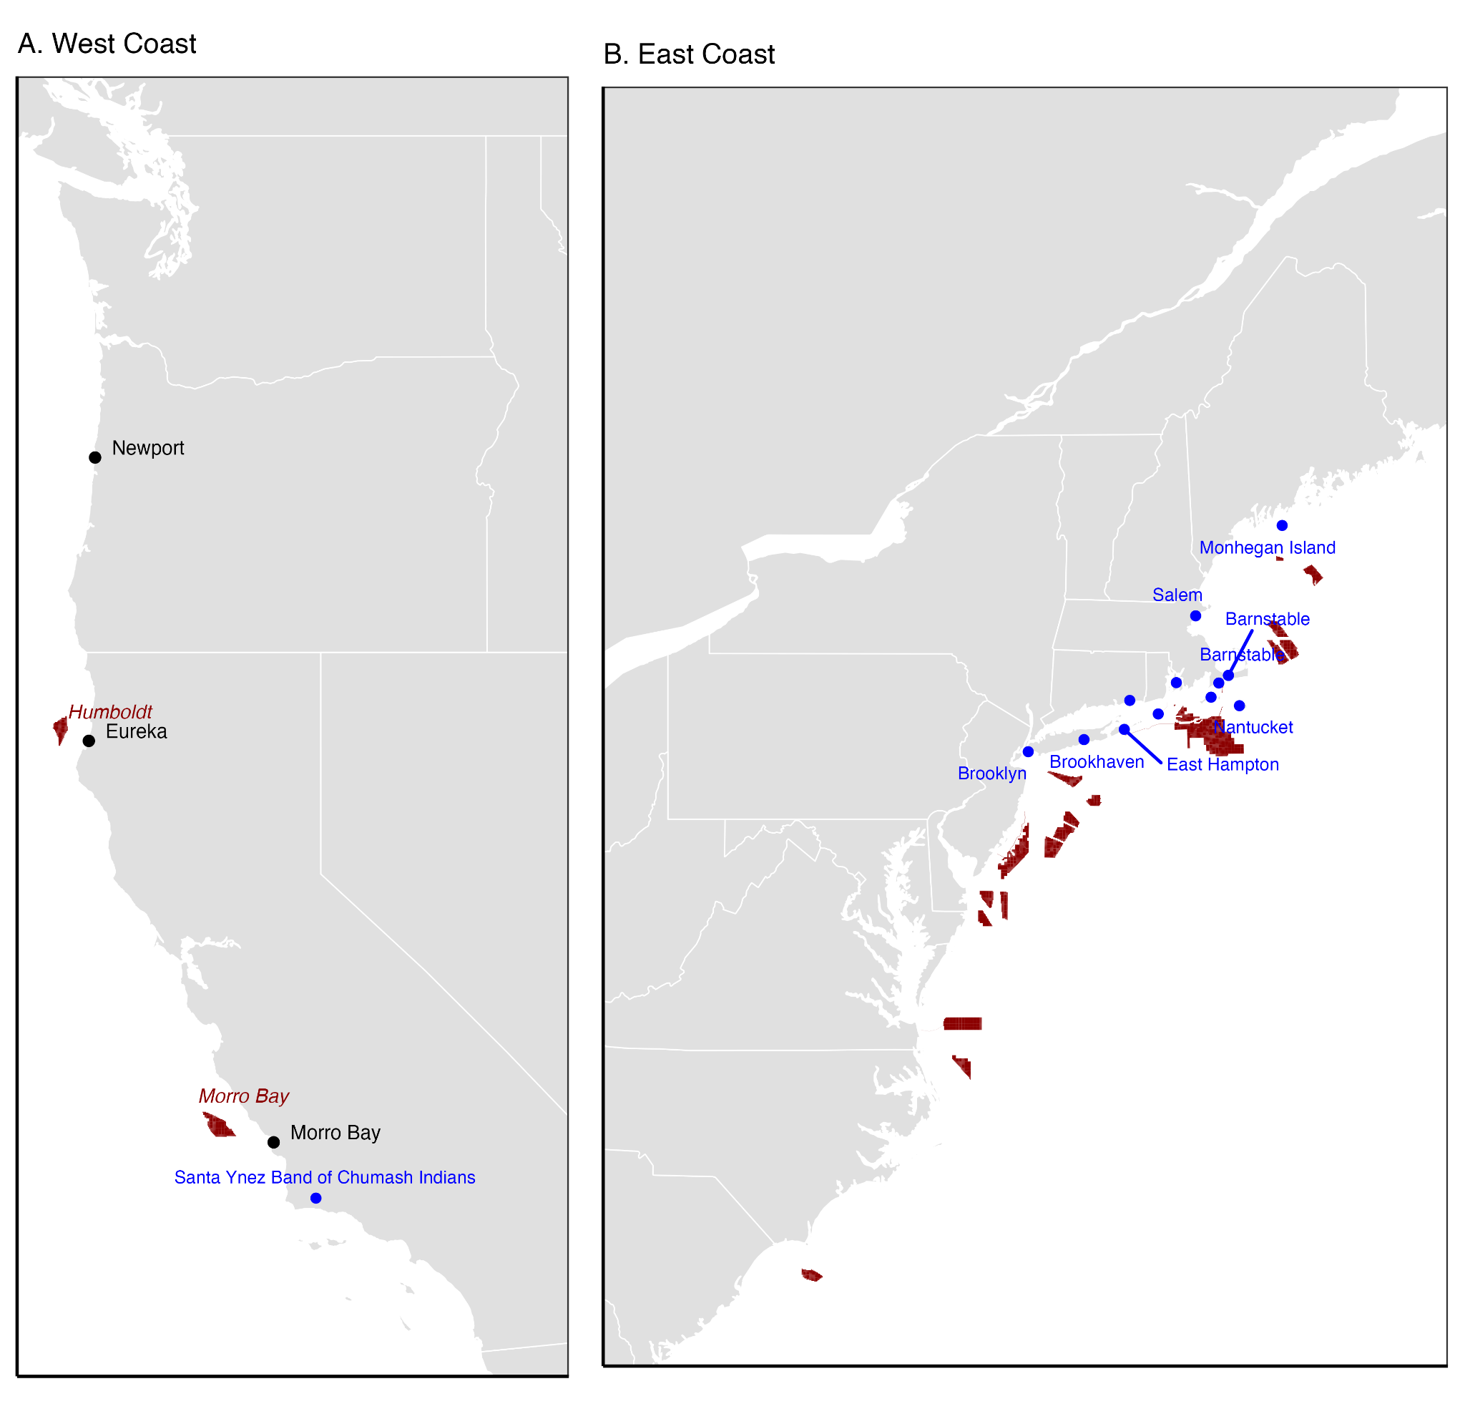
Figure 1. The location of offshore wind lease areas off of the U.S. (A) West Coast and (B) East Coast. Maps show lease areas (red polygons and labels), places with community benefit agreements (CBAs) established between developers and communities (blue points and labels), and focus groups with West Coast fishing communities (black points and labels).

To-do list:
- Add inset map of US (top-left of panel B)
- Mark leases as developed or planned
- Clear up CBA town labels

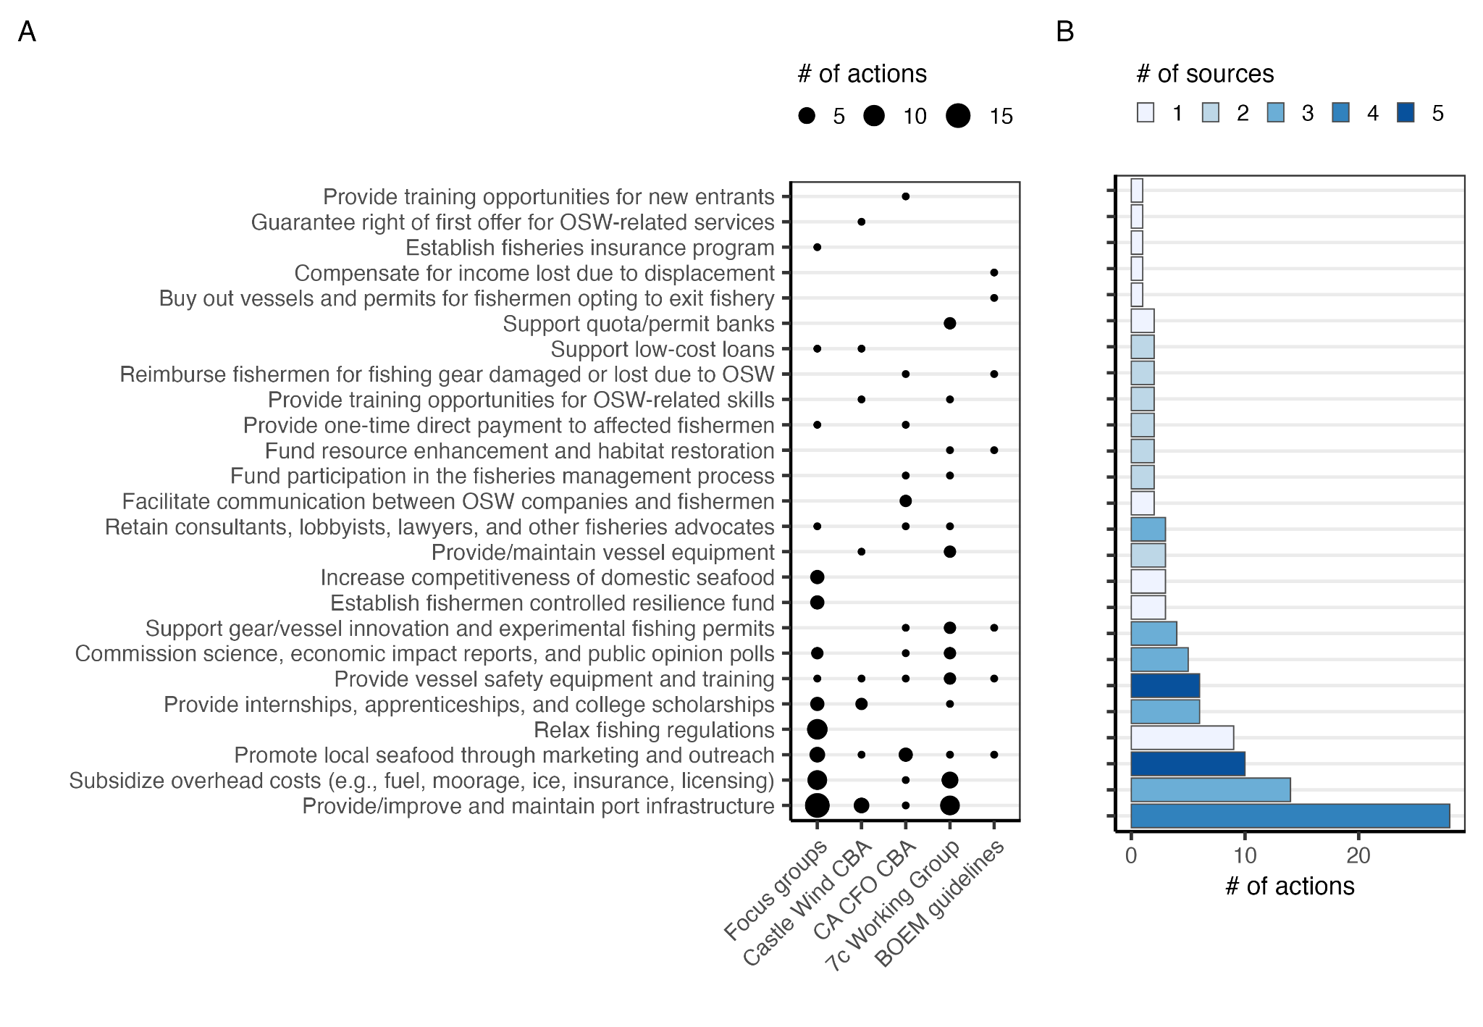Figure 2. The number of actions associated with different mitigation strategies (A) by source and (B) across sources. Acronyms: CBA=community benefit agreement; CA=California; CFO=commercial fishing organization; BOEM=Bureau of Ocean Energy Management.

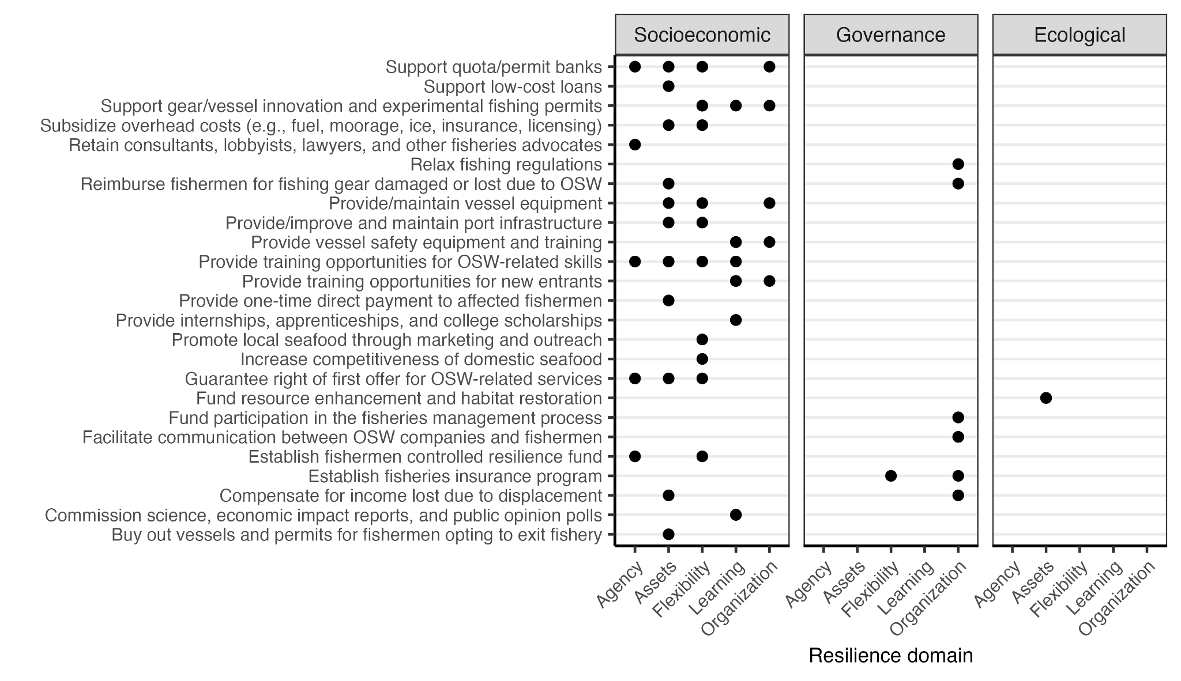Figure 3. Resilience domains supported by each mitigation strategy. The governance dimension does not have an Assets domain and the ecological dimension does not have either Agency or Learning domains.

To-list:
- Remove irrelevant domains (Gov-Assets; Eco-Agency/Learning)
- Highlight unsupported domains
- Highlight how many strategies support each domain? Maybe with (n=X)
- Convert to tile and use Mason et all colors?
- Think about grouping of mitigation strategies (y-axis)

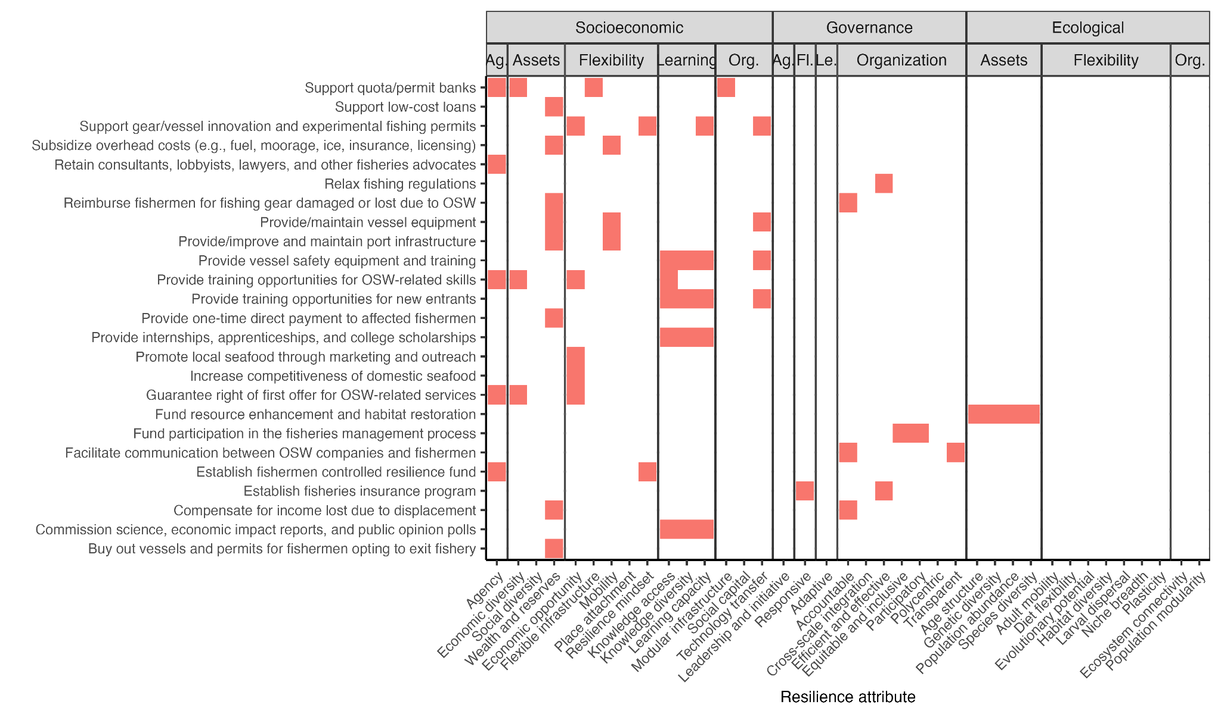Figure 4. Resilience attributes supported by each mitigation strategy. Attributes are organized by their dimension (socioeconomic, governance, ecological) and domain (agency [Ag], assets, flexibility, organization [Org], and learning [Le]) of climate resilience.

To-do list:
- Make less squished
- Use Mason et all colors?
- Sort attributes by amount of support?
- Think about grouping of mitigation strategies (y-axis)
- Think about whether it's important to show the unsupported attributes (they make it squished)

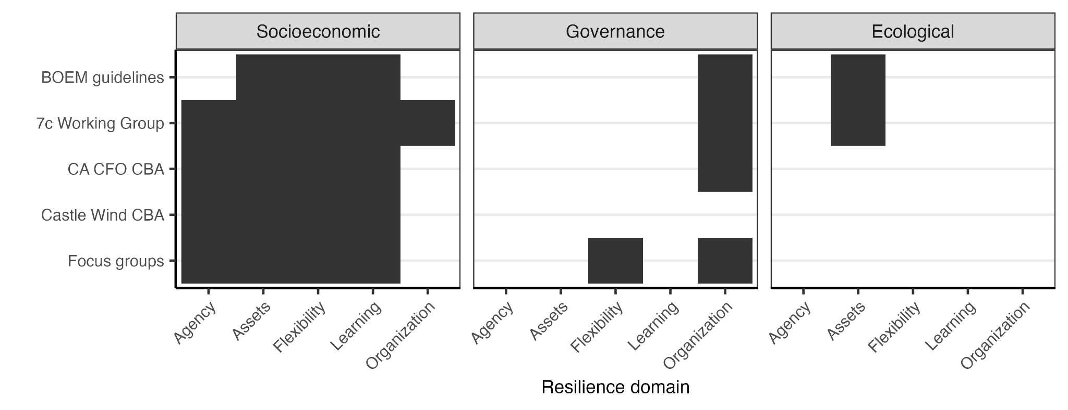
Figure 5. Resilience domains supported by mitigation strategies proposed within each source.

To-list:
- Remove irrelevant domains (Gov-Assets; Eco-Agency/Learning)
- Use Mason et all colors?
- Sort from greatest to least support by source

Appendix A: Focus group materials
This will not be included in the BOEM report.

